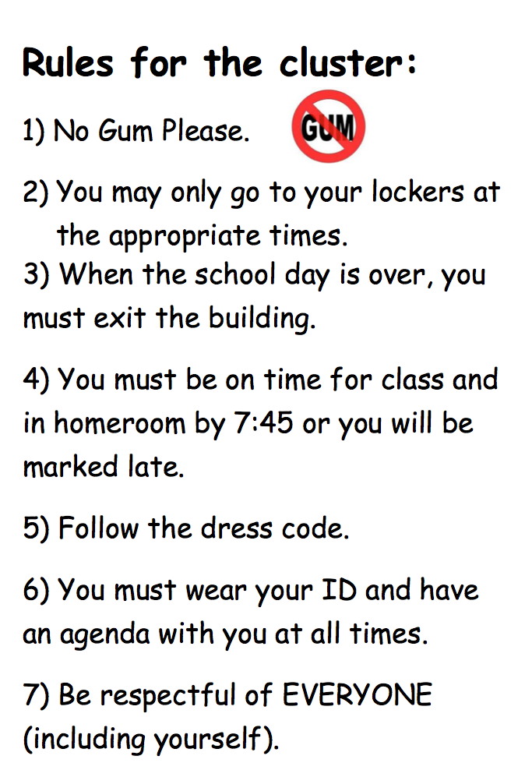

Procedures: How we do things here.
1) Entering class: Come in quietly and on time. Take your seat and begin your "do now" work.

2) When you finish, take out your homework and put it on your desk.

During class:
1) Papers that need to passed out and collected will be done by a student who is assigned for that week.
2) All papers being collected will be placed in the center of the group.

